**LAB SHEET NO.6 [To be familiar with FUNCTIONS:]**

1.Write a program to add, subtract, multiply and divide two integers using user defined function add(), sub(), mul() and div().

**Code:**

#include<stdio.h>

void add(int a,int b)

{

int c;

c = a+b;

printf("the sum of %d and %d is %d",a,b,c);

}

void sub(int a,int b)

{

int c;

c = a-b;

printf("\nthe subtraction of %d and %d is %d",a,b,c);

}

void mul(int a,int b)

{

int c;

c = a*b;

printf("\nthe multiply of %d and %d is %d",a,b,c);

}

void div(int a,int b)

{

float c;

c = (float)a/b;

printf("\nThe division of %d and %d is %f",a,b,c);

}

int main()

{

int a,b;

printf("Enter any two numbers:");

scanf("%d%d",&a,&b);

add(a,b);

sub(a,b);

mul(a,b);

div(a,b);

return 0;

}

Output:

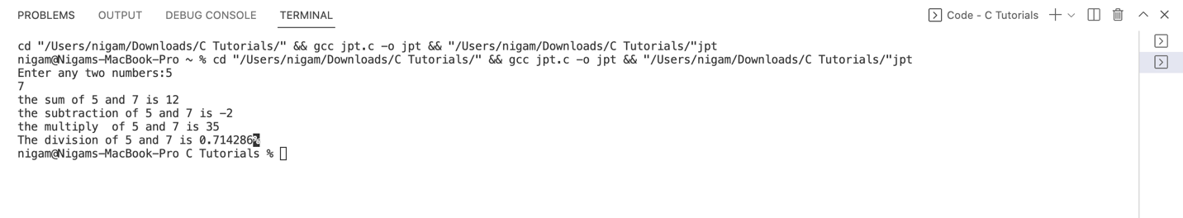

2.WAP to display sum of series: x + x2/2! + x3/3! + x4/4! + x5/5! ... xn/n!. User defined function factorial() and power() should be used to calculate the factorial and power.

**Code:**

#include<stdio.h>

#include<math.h>

int factorial(int n)

{

if(n==0||n==1)

return 1;

else

return (n*factorial(n-1));

}

int power(int x,int i)

{

return pow(x,i);

}

int main()

{

int n,x,fact,i;

float sum=0.0;

printf("Enter the value of n:");

scanf("%d",&n);

printf("Enter the value of x:");

scanf("%d",&x);

for(i=1;i<=n;i++)

{

sum = sum + (float)power(x,i)/(factorial(i));

}

printf("the sum of series is %f",sum);

return 0;

}

Output:

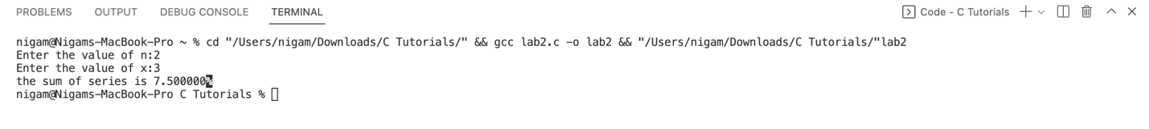

3.WAP to calculate factorial using Recursion.

**Code:**

#include<stdio.h>

int factorial(int n)

{

int fact;

if(n==0||n==1)

return 1;

else

return (n*factorial(n-1));

}

int main()

{

int n,fact;

printf("Enter the value of n:");

scanf("%d",&n);

fact=factorial(n);

printf("%d! = %d",n,fact);

return 0;

}

Output:

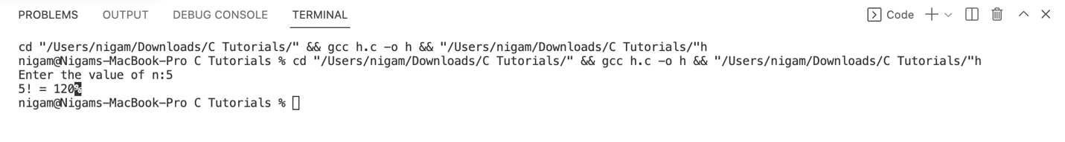

4.WAP to display the nth Fibonacci number using recursion.

**Code:**

#include<stdio.h>

int factorial(int n)

{

int fact;

if(n==0)

return 0;

else if(n==1)

return 1;

else

return (factorial(n-1)+factorial(n-2));

}

int main()

{

int n,i=0,c;

printf("Enter the number of terms in series:");

scanf("%d",&n);

printf("fibonacci series\n");

for(c=1;c<=n;c++)

{

printf("%d\n",factorial(i));

i++;

}

return 0;

}

Output:

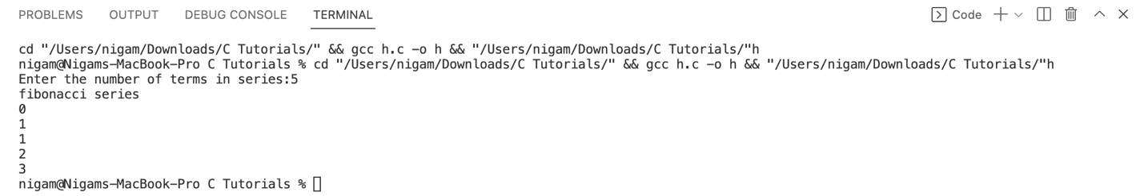

5.WAP to take two numbers in main(). Write a function Swap() to swap the values of the variables. Print the swapped values in main().

**Code:**

#include<stdio.h>

void swap(int *a,int *b)

{

int temp;

temp=*a;

*a=*b;

*b=temp;

}

int main()

{

int a,b;

printf("Enter any two number:");

scanf("%d%d",&a,&b);

printf("The numbers before swapping are: a = %d and b = %d\n",a,b);

swap(&a,&b);

printf("The numbers after swapping are: a = %d and b=%d",a,b);

return 0;

}

Output:

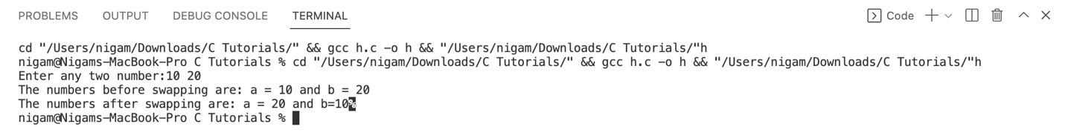

6.WAP to take two float number in main(). Write a function single user define function calculator() to perform the addition, subtraction and multiplication. The sum, difference and product should be displayed from the main() function. [Use the concept of pass by reference.].

**Code:**

#include <stdio.h>

void calculator(float *a,float *b,float *Ans)

{

char operator;

printf("Enter '+' for addition '-' for subtraction '*' for multiplication: ");

scanf(" %c",&operator);

switch (operator)

{

case '+':*Ans=*a + *b;

break;

case '-':*Ans= *a- *b;

break;

case '*':*Ans= *a * *b;

break;

default:

printf("Enter a valid operator.");

break;

}

}

int main()

{

float a,b,Ans;

char c;

int d;

printf("Enter any two numbers:");

scanf("%f%f",&a,&b);

do

{

calculator(&a,&b,&Ans);

printf("%f",Ans);

printf("\n enter y for more calculation\n");

scanf("\n%c",&c);

} while (c=='y');

return 0;

}

Output:

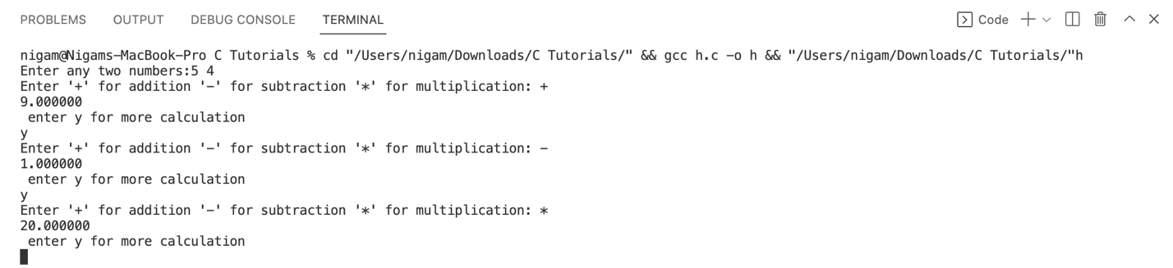

7.WAP to input a integer number int main( ). Write a user define function isPrime() to calculate whether the number is prime of not. Print whether the number is prime or not from the main().

**Code:**

#include<stdio.h>

int isPrime(int n)

{

int flag=0,i;

if(n==0||n==1)

return 0;

else

{

for(i=2;i<n;i++)

{

if(n%i==0)

{

flag++;

break;

}

}

}

return flag;

}

int main()

{

int n,flag;

printf("Enter a number:");

scanf("%d",&n);

flag=isPrime(n);

if(flag==0)

{

printf("%d is a prime number",n);

}

else

printf("%d is not a prime number",n);

return 0;

}

Output:

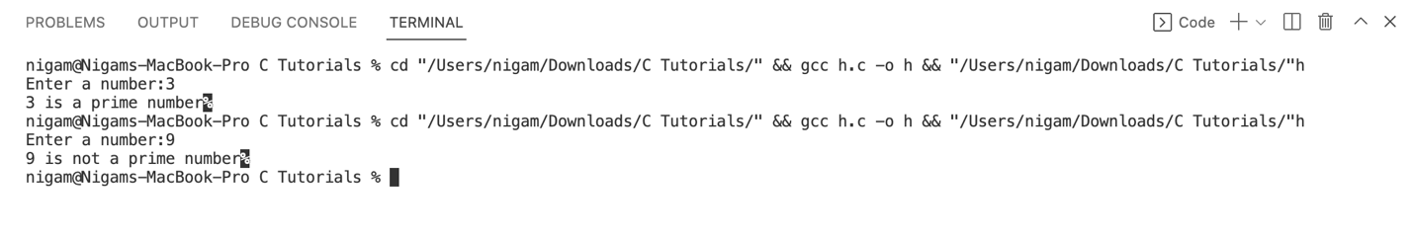

8.WAP to illustrate the concept of global and static variables.

**Code:**

// for static variable

#include<stdio.h>

void counter()

{

static int count;

count ++;

printf("Function called %d times\n",count);

}

int main()

{

counter ();

counter();

counter();

counter();

return 0;

}

Output:

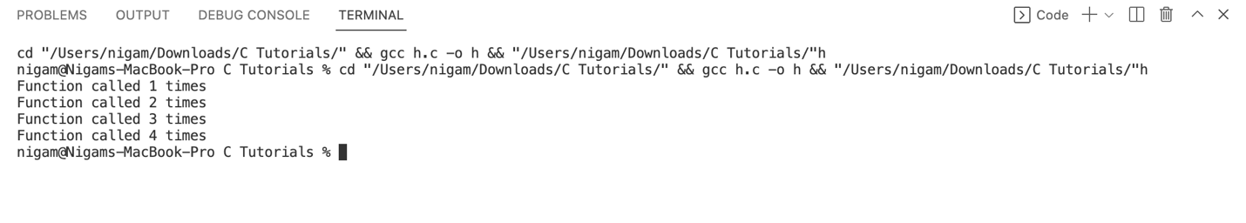

For global variable…

**Code:**

#include<stdio.h>

int a,b=10; // Global variable

void function_1()

{

printf("From function_1 a=%d\t b=%d\n",a,b);

}

void function_2()

{

a=20;

b=30;

printf("From function_2 a=%d\t b=%d\n",a,b);

}

void function_3()

{

printf("From function_3 a=%d\t b=%d\n",a,b);

}

int main()

{

printf("From main a=%d\t b=%d\n",a,b);

function_1();

function_2();

function_3();

a=25;

function_3();

function_1();

return 0;

}

Output:

